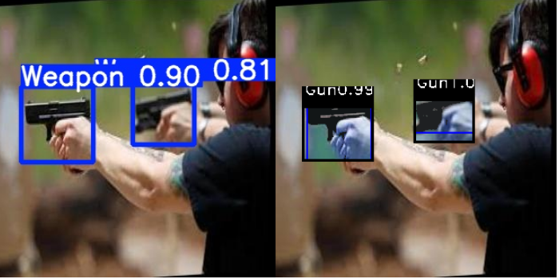 | Gun
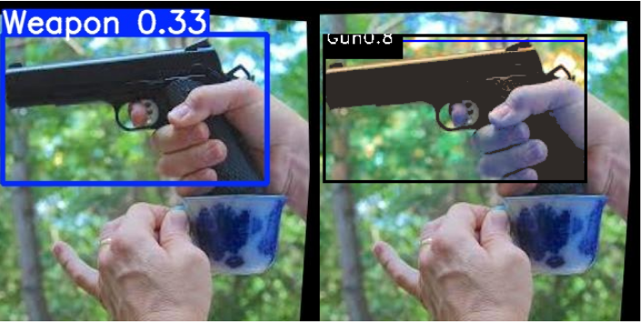 | Gun
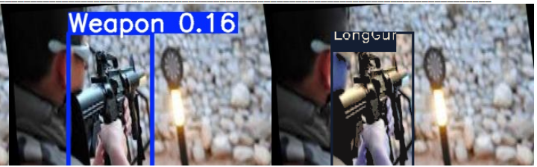 | LongGun
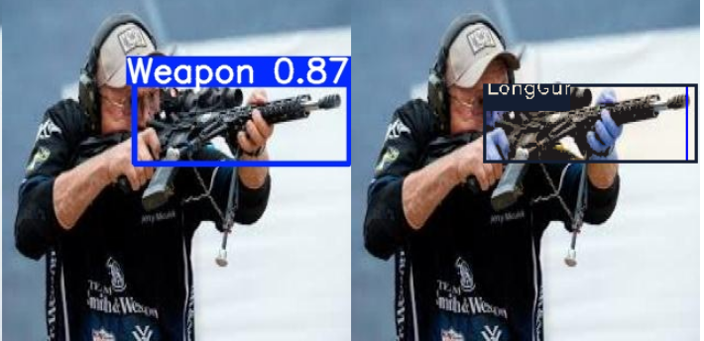 | LongGun
- Sample of detections with re-localization
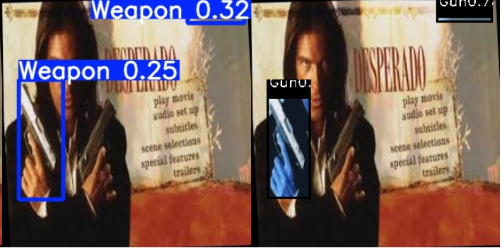 | Missing Gun by 1st stage and FP not rejected by 2nd stage
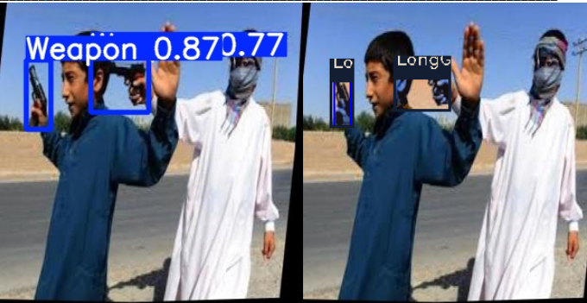 | Miss classify by 2nd stage
- Sample errors of missings or false-positive detections
- Sample detection of proposed model on footage dataset. Detections of different classes are shown as second stage output after passed by first satge as one class “weapon”

